**Portfolio 1.1**

**Paper Kraft’s website development**

Praphat Chungyampin

Student ID: 12084314

COIT 20268 Responsive Web Design (RWD)

(Term 2 – 2018)

This website development provides information to customers who look forward to Paper Kraft's product and visit the shop front.

**Planning the site:**

***Paper Kraft*** is a crafting shop operates by sole-proprietor which has sold 3 categories of craft products including

1. Art diary, containing 7 special diary books that made from many special processes and decorating.
2. Artist trading cards which were designed by renowned artists and this season collection including 7 styles.
3. Paper structures which representatives from the really famous location that were designed and calculated with the excellence proportion. It’s suitable for house decoration and even for helping skill development that containing 5 design patterns.

Approaching to grow up and sale increasing, Paper Kraft has a developing plan and engaging with their customer by using an online website as well as they chose to consult with our team as WIMP Engineering R&D Consultants to create and design the exceptional website.

By developing the website, the designer has identified and analyzed many points to display overall ideas and demonstrate graphical prototype in detail:

**Main element outline:**

* !DOCTYPE html
* html
* head
* title
* meta
* style
* body
* footer

**Navigation content compounding with,**

* + **Welcome message** to greeting and navigating the user to find and get information easily
  + **Shop floor/ map** to represent the exact layout design that makes convenience for the customer who plans to visit and look for each section in the shop directly
  + **About us,** to describe the company background, who we are, and how professional we serve to the customer.
  + **Our product,** which classify and detail collection of Paper Kraft’s product, this section would be created into detail layer page such as artist’s name, idea creation of the masterpiece, and entire crucial information.
  + **Contact detail,** to support and answer any inquiry from user**.**

**Target audience**

According to research, trending of craft as a hobby has been increasing recently by 63% of US residents participating in the craft of hobby activities in 2016 by 6,209 samples. It was one-third (31%) of US household in the paper crafts category. In addition, the result also mentions that they felt proud in term of emotions analysis. Those of participate gain extremely a sense of accomplishment and feeling of relaxation with high enjoyable life scoring.

Demographics among this paper craft that demonstrate the high percentage of 63 was female more than male,

Thus, the designer has demonstrated the target audiences which classified into 3 groups as

* Mainly, the female who age between 25-55 years old which generic information was a college education, stay slightly out of the city and most of them work more than 30 hours a week.
* Secondary, focusing on children and school staffs who spend available time and classroom activities to create and practice their skills on the product as paper structure, moreover, they can work as a team also.
* On the other hand, the designer also focuses on wholesaler, exporter, and distributor who are looking for the craft product for sale to the retailer in other distance.

Main target group profile: ***Female***

*Demographic:*

* + Gender: female
  + Age: 25-55 years old.
  + Income: $25,000- $50,000 annually
  + Education: college
  + Location: Suburban
  + Employment: Full-time

*Psychology and lifestyle:*

* + Treasuring in design and product uniqueness.
  + Appreciating the artist’s talent, DIY products.
  + Loving decoration, furniture, interior.
  + Spending weekend time, available time with their family.

Secondary target group profile:***Children and School staffs***

*Demographic:*

* Gender: male and female
  + Age: 8 - 15 years old.
  + Education: element school, junior high school

Third target group profile:***Wholesale, exporter and distributor***

*Demographic:*

* + Gender: male and female
  + Age: 25-55 years old.
  + Income: $25,000- $50,000 annually
  + Education: college degree
  + Location: urban
  + Employment: Full-time

*Psychology and lifestyle:*

* Spending time to survey in office for trading and analyzing overall benefit.
* Focusing on the job mainly.
* Having well negotiating, managing and communicating skills

**Design considerations**

* + ***Customer’s specification***, the overall details from Paper Kraft prefer to provide information to customer who wants to visit the shop rather than online selling. Greeting message and floor plan would be following. In addition, the other requirements such as pop up the new page for the business hour.
  + ***Navigation*** to each page easily and clearly understanding. No error or mistaken during information switching.
  + ***User’s insight***, designer, and developer should survey to get the end user’s insight about how to use, how to link the site and useful feature. Moreover, the team should consider the process or procedure if they were the customer and allow anyone to test the prototype.
  + ***Responsive design*** which supports entire using devices such as desktop, mobile, and tablet.
  + ***Theme, color, font types and sizes*** to attract the target group. In this case, the end user target group is the woman that should be considered about the color and theme to target this group. Age between 25-55 years old which may meet the problem with the font size and font style. The color shouldn’t be both extremely brighten and similar color with the background which lead to reading hardly.
  + ***Website aesthetic***, overall design should be the balance, do not contain unnecessary point or overwhelming detail in one page. The color and theme design should be similar in total to let the end user comfortable to stay with the webpage.
  + ***Efficiency hyperlink***, when the end user clicks on the pictures and can be connected to the proper site. For instance, clicking on the display section (red lettering in round boxes) which should bring up tailor to relevant item’s information.

**Limiting factors to interface web designing**

***Web design environment issue***

* ***Usability skills*** which the end user couldn’t have enough basic knowledge to use webpage. This might lead the end user to leave the webpage within a moment of time. In addition, designer and developer would understand overall requirement and needs of website using by considering the target audience’s behavior and how do they expect to use generally. For instance, gathering information with surveying to know their insight and also prevent some misunderstanding or develop prototype and trial with target audience.
* ***Consistency and responsive designing*** generally, the layout of website design should be harmony with the entire outlook of website which means the basic framework and structure containing text, navigation, images which end user can spend less time to find out and engage with content.
* ***Compatibility with multiple browsers***, different site browser may use the different codes which generate issue as a design in final step. Crossing browser compatibility issue would be caused by any error within site code. For instance, Google Chrome reads and shows the website differently when compared to Explorer.

***Technical issue***

* + ***Technology and platform,*** web design would create an error or incompatible during running platform or even upgrading technology that might affect to the existing web design.
  + ***Screen resolution with vastly differing devices****,* nowadays technology has been developed and created a new version and plenty of sizes of product which allows the developers work difficulty. The different design and variety of device would display and response some errors or aesthetic appearance, for instance, the white space area changing, as well as the left and right area spacing. Thus, the designer and developer would consider the pattern and design properly during the drafting stage.
  + ***Accessibility***, which relates to how the design will be implemented and interacted. Moreover, it also includes the technological barrier such as graphical color which varies and limit to different devices which also display different output of color. Thus, designer should aware on some point of contrast version and font size.
  + ***Disability***, the issue that relates to physical ability of users who may have deuteranopia, protanopia, tritanopia or total color blindness. That they can see the color error from normal vision.
  + ***Poor connectivity and bandwidth*** especially happened with slow download speed on smart devices. For instance, if using EDGE network to download speed might be miserable.

***Another issue including*** which designer has to consider as development challenging such as coding between desktop and mobile phone, the expectation for function design, web browser as well as lack of regulation.

**Portfolio 1.2**

**Layer 1: display the over picture of main page**

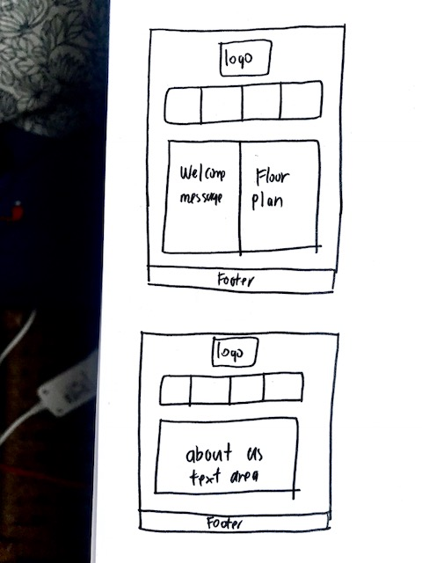

**Layer 2 : display the detail of menu bar**

**about us product lists contact working hour**

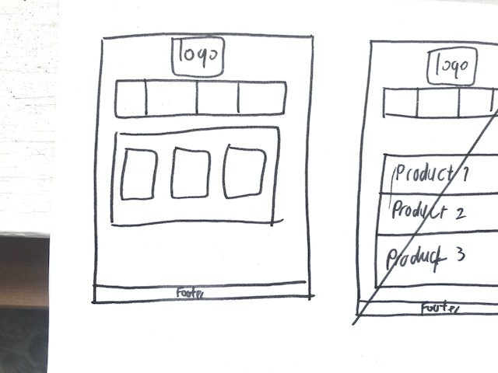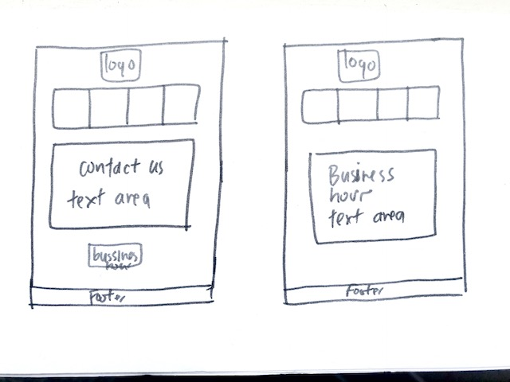

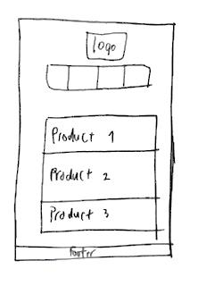**Layer 3: display the detail of product lists (art diary, artist trading card, paper structure)**

**­­**

**Portfolio 1.3**

***Mission statement***

This website demonstrates the entire information of Paper Kraft’s shop including the business profile, product’s information, contact detail, shop floor which been created for end user to get overall tailors conveniently. The developer and designer will accomplish by researching end user’s insight, using many skill sets of coding with HTML and CSS to contribute the exceptional design and consider using this website easily.

***To measure*** the successful site in meeting its goals, the developer should define and determine the SMART (specific, measurable, attainable, realistic and time-bound) goals, in term of achievement. For instance, sale amount, promote business and make the brand awareness or even increase the customer engagement. Then, all goals are into action.

When the goals were set up, our developer would measure how success we are by using Google Analytic Tool which calculates and analyst our website.

* + - 1. ***Number of website visitors***, high traffic would inform the customer support sites.
      2. ***Bounce rate,*** is amount of user who leave the page before visit another link. It means they look at only the first page. If this percent is high, that might be not good for website.
      3. ***Average time on page***, which is average amount of visiting time in page. For instance, user spent 10 seconds for average time which assumes most of visitors might not read our post
      4. ***Sale amount,*** which compare between before and after website development
      5. ***Satisfaction survey and feedback form***

***To describe user satisfaction***, in the beginning period, designer and developer should understand target audience’s insight and their experience to achieve with positive satisfaction feedback. This would include surveying and interviewing to know general problems that they met and want to improve and aware. Generally, user meet problem with

**Browser issue**: normally, the issue will happened when using different browser. The solution of this issue is to test with many browsers across operating system whether it display properly as well as it is crucial to have latest version browser.

**Screen resolution**: during plenty design and size of devices which reflect to the usability and different device’s display. The most common screen solution is 1024x768 pixels, in case of lower or higher resolution may display with possibly errors.

**Download speed**s: currently, the internet is compounding with variety of speed. Not all users can access the high-speeding. So, the webpage design would be affected from this vary speed also. When design the website, designer should consider the quantity of images and files, size and types, which may spend much time to download. This can result user to leave the webpage eventually.

**Coding technology**: it is one factor which can affect indexing and stop user from viewing the website including HTML frams, Flash, Jascript, Flash, AJAX. When using these technologies, team should consider the possible risk to access and use website. .

Product-card trading.html

Product-diary.html

­­­­

Floor_Plan.jpg

Paper Kraft

Product list.html

Product-paper structure.html

About us.html

Navigation/ content bar

Business hour.html

Contact us.html

Home.html

This figure illustrates the website design flowchart of each step when the user enters to the main website, they will attract with the welcome message and ***floor plan i***mage as well as this image can link to each category of the product by using mouse over the picture session. In the other hand, the user can use the ***navigator*** bar for linking directly into any page.

The content of the menu tab includes 4 parts as ***“home”*** which presents the landing page and convenience to link back when using other pages. Secondly, ***“about us”*** that demonstrates the company profile and how professional they do serve. Thirdly, ***“our product***” that link to the whole item lists describing product’s detail, the collection they do have, price and also the main idea that originators who would like to communicate. Lastly, ***“contact us***”, represents the venue which user would like to communicate with our shop, ask any inquiry, appointment or any complaint to shop. Beside this page, it includes the business hour hypertext link which ready to pop up into the new webpage separately.

This website development performs with ***hierarchy structure*** which is a suitable structure according to client’s requirement. The balancing of correlation is crucial in term of website design efficiency that focusing of the main/home page with separate content pages and altogether would be connected by linking around a single home page. In the other hand, the goal of this hierarchy structure designing is to build the menus and content pages that connect smoothly backwardly and forwardly and doesn’t mislead.

In addition, most users could familiar and understand how to navigate easily and this is ***beneficial*** to the user who visits website could find their information faster, easier which means the user will intend to stay longer as well as pay attention to website’s information also.

***Filename:***

Paper Kraft

Index.html

Contact.html

About us.html

Product-diary.html

Product list.html

Product list.html

Product-card trading.html

Product-paper structure.html

Business hour.html

Logo.png

map.png

Floor_plan.jpg

AD5.jpg

TC1.jpg

AD7.jpg

AD6.jpg

TC2.jpg

TC3.jpg

TC6.jpg

TC5.jpg

TC4.jpg

TC7.jpg

AR1.jpg

AR4.jpg

AR3.jpg

AR2.jpg

AR5.jpg

AD3.jpg

AD2.jpg

AD1.jpg

AD4.jpg

***Wireframe layout* Layer 1: display the over picture of main page**

Floor plan

Welcome message

**footer**

**About us Product Contact Working hour**

**Logo**

**­­**

**Layer 2 : display the detail of menu bar**

**about us product lists contact working hour**

Contact detail

**footer**

Map

**About us Product Contact Working hour**

Art diary

**footer**

**About us Product Contact Working hour**

**Logo**

**Logo**

**footer**

**Contact**

**About us Product Contact Working hour**

**Logo**

Company profile text Information

**footer**

**About us**

**About us Product Contact Working hour**

**Logo**

Artist card

Paper structure

**Business working hour**

**Layer 3: display the detail of product lists**

**art diary artist trading card paper structure**

**Artist trading card**

**footer**

TC1

Product information

TC2

Product information

TC3

Product information

**About us Product Contact Working hour**

**Logo**

**Paper structure**

**footer**

AR1

Product information

AR2

Product information

AR3

Product information

**About us Product Contact Working hour**

**Logo**

**Art diary**

**About us Product Contact Working hour**

**footer**

AD1

Product information

AD2

Product information

AD3

Product information

**Logo**

**­­**

**Portfolio 1.4**

***.title*** { grid-area: title; height: 75px;}

***.header*** { grid-area: header; text-align:center; font-family:'Oleo Script', cursive;}

***.sidebar*** { grid-area: sidebar; height: auto;}

***.content*** { grid-area: content; height: auto; color: rgba(119,206,215,1); font-family: 'M PLUS Rounded 1c', sans-serif; }

***.footer*** { grid-area: footer; text-align:center; clear:both }

***.grid*** {

grid-template-columns: 1fr 400px 400px 1fr;

grid-template-rows: 80px 40px 1fr 25px;

grid-template-areas:

". title title ."

". header header ."

". sidebar content ."

". footer footer .";}

.title

.header

.footer

.sidebar

.content

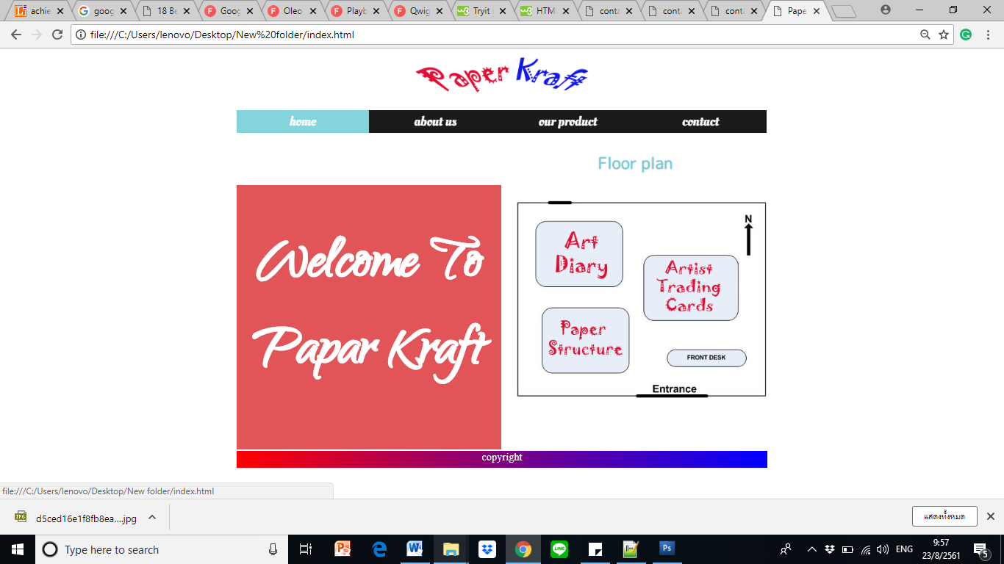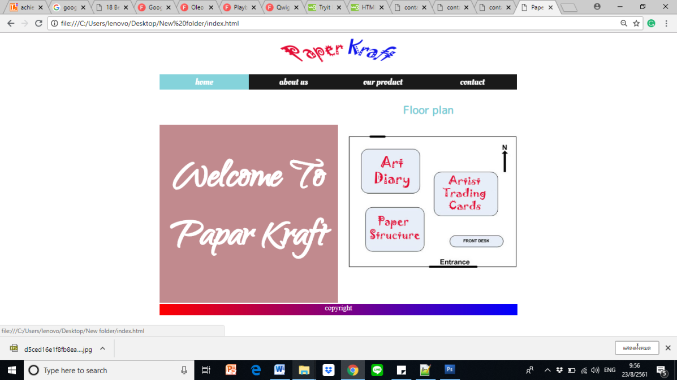

***ul*** {margin: 0px; padding: 0px; list-style: none; }

***ul li*** {float: left; width: 200.5px; height: 35px; background-color: black; opacity:.9; line-height:35px; font-size:20px; display: block; }

***ul li a***{ text-decoration: none; color: white; display: block; }

***ul li a:hover*** {backgroundcolor: rgba (119,206,215,1);

***.content*** {

h2 {text-align: center}

img { float:center; width:420px; usemap="floor plan"}

<area shape="rect" coords="57,60,204,163" alt="art diary product" href="product-diary.html"/>

<area shape="rect" coords="261,134,413,229" alt="artist trading card product" href="product-card trading.html"/>

<area shape="rect" coords=" 78,225,222,323" alt="paper structure product" href="product-paper structure.html"/> }

</map>

</div>

***#myDIV*** { background: red;

-webkit-animation: mymove 5s infinite; animation: mymove 5s infinite; height: 400px; }

@-webkit-keyframes mymove {from {background-color: rgba(228,25,28,.8);} to {background-color: rgba(119,206,215,.8);} }

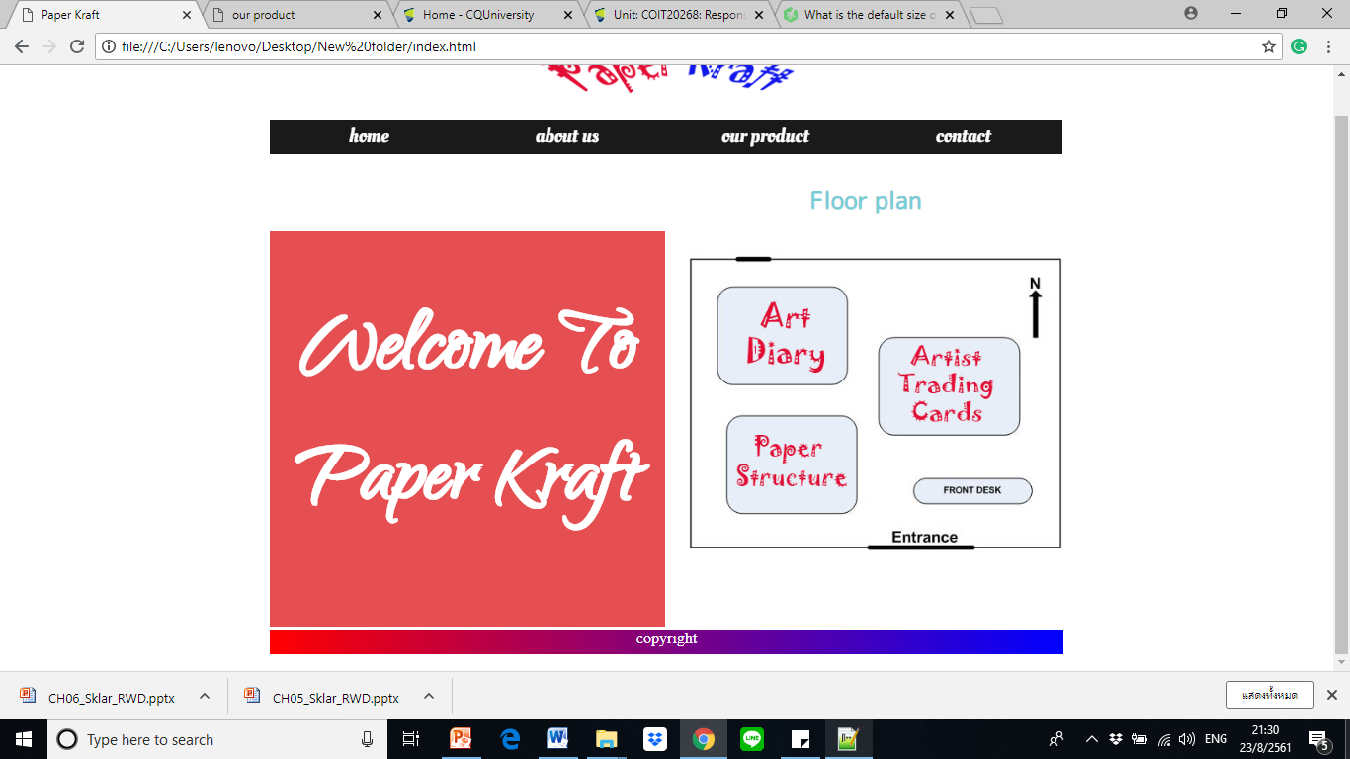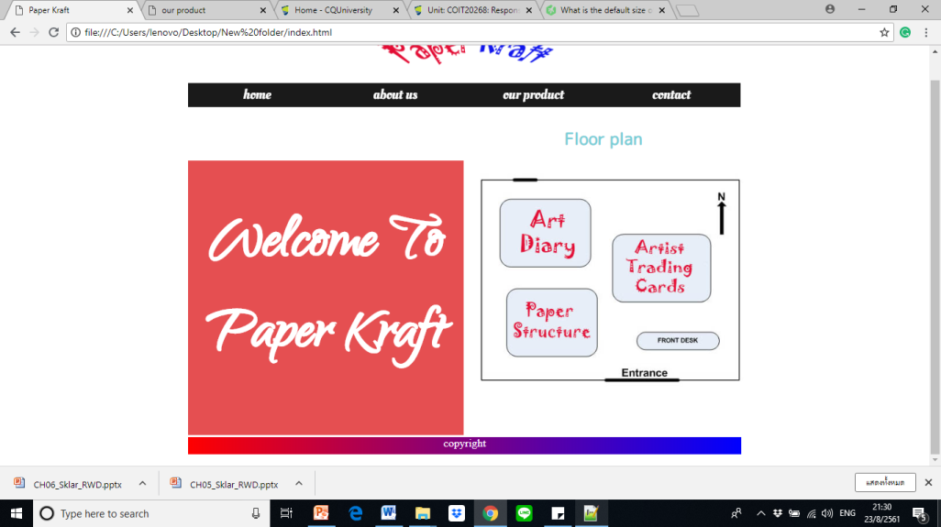

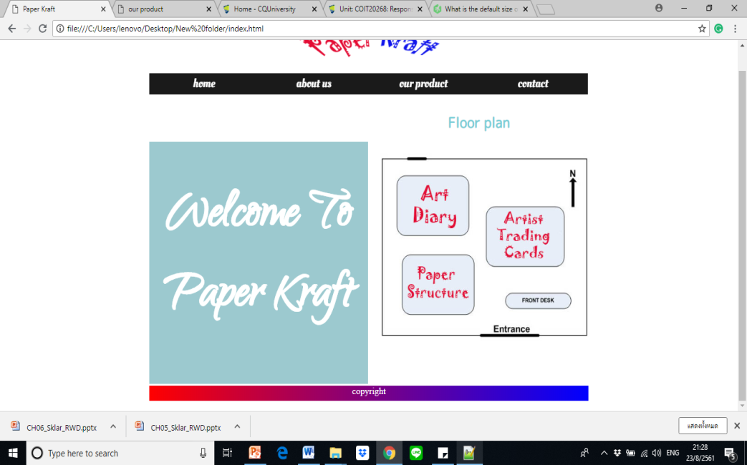

***H2*** {text-align: center; padding:1em; text-shadow:1.5px 1.5px grey; }

***p*** {text-align: left; padding:2em; font-size: 18px; text-indent: 50px; }

***.content*** {background-color: rgba (228, 25, 28,.8) ; color: white; }

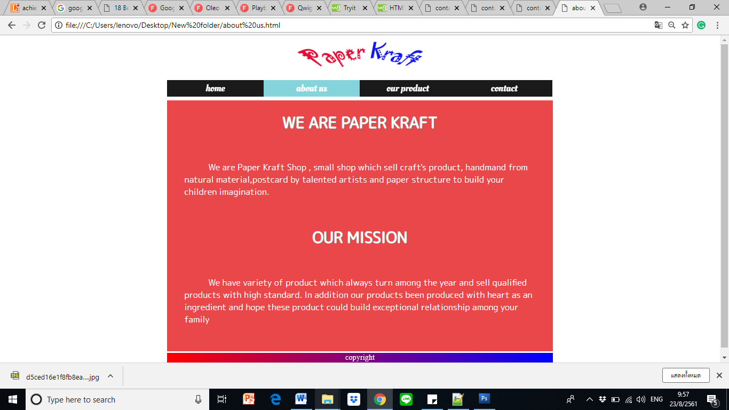

***.footer*** { "background-image: linear-gradient(to right, red , blue);color: white;}

***.logo*** {max-height: 200px; max-width: 280px; }

***img*** {max-height:150px; max-width: 250px;}

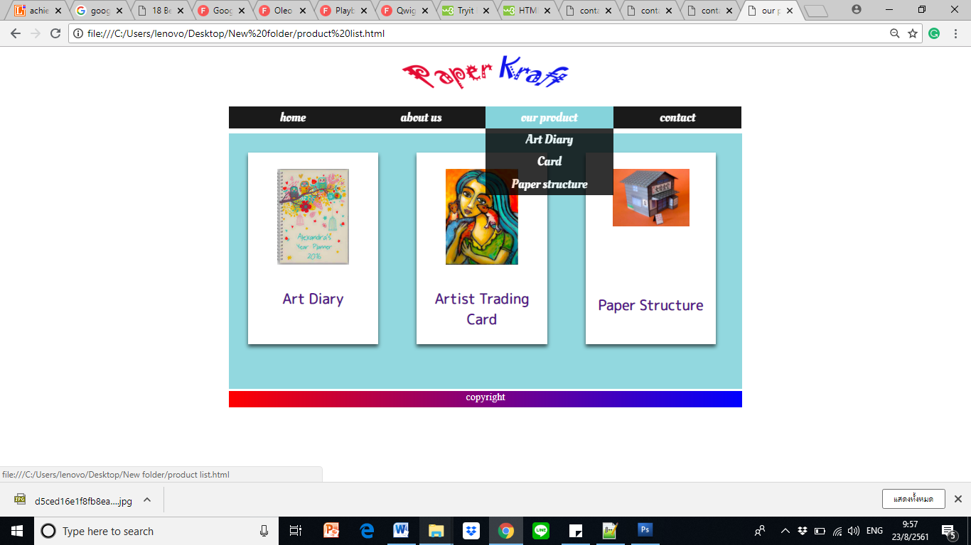

***.card*** {box-shadow: 0 4px 8px rgba (0,0,0,0.6); transition:0.4s; width:200px; height: 250px; text-align: bottom; padding :25px 2px; font-size: 22px; float: left; margin:30px; background-color: white;}

***h3*** {text-align: center; padding-top:5px; }

***ul li ul li*** {display: none; }

***ul li: hover ul li*** {display: block; }

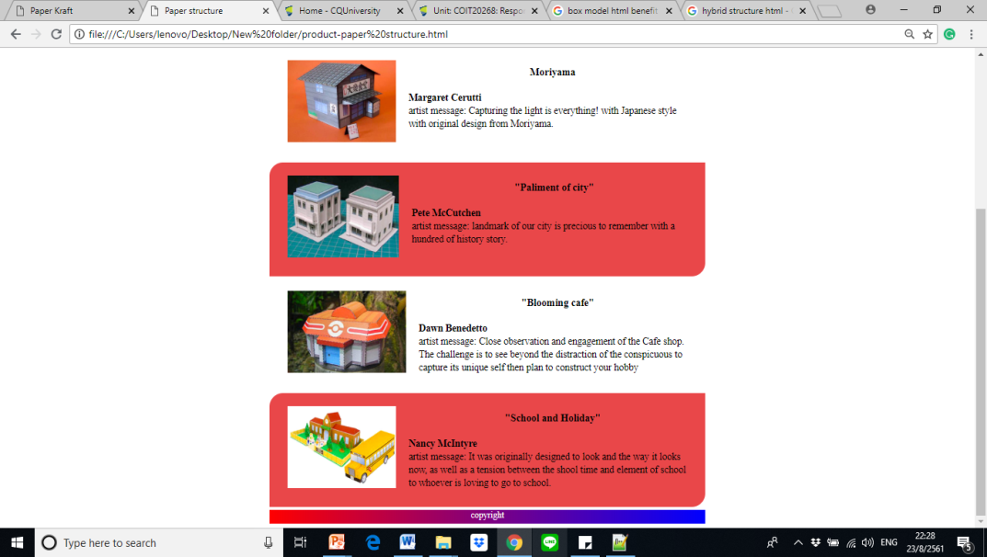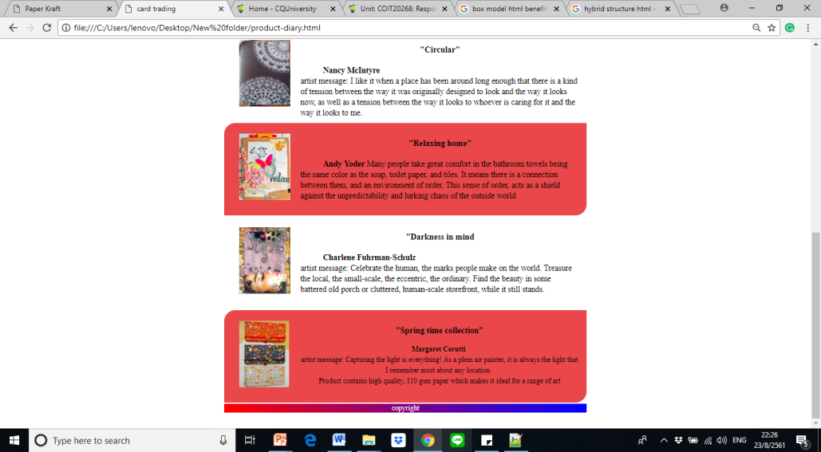

***img*** {max-height:150px; max-width: 250px; padding: 10px;}

***.float-img*** {float: left; margin-right: 8px; margin-left: 8px; padding-right: 15px; clear: left; }

***h1*** {padding-top: 5px; text-align: left; padding-left: 10px; }

***p*** {text-align: left; padding:5px; font-size: 18px; text-indent: 50px; }

***.block*** {background-color:#37b49b; float: left; padding:15px; margin-bottom: 2px; width: 773px; height: 180px; font: 16px center; background-color: rgba(228,25,28,.8); }

***.container*** {width: 100px; float: auto; opacity: .9; align: center; }

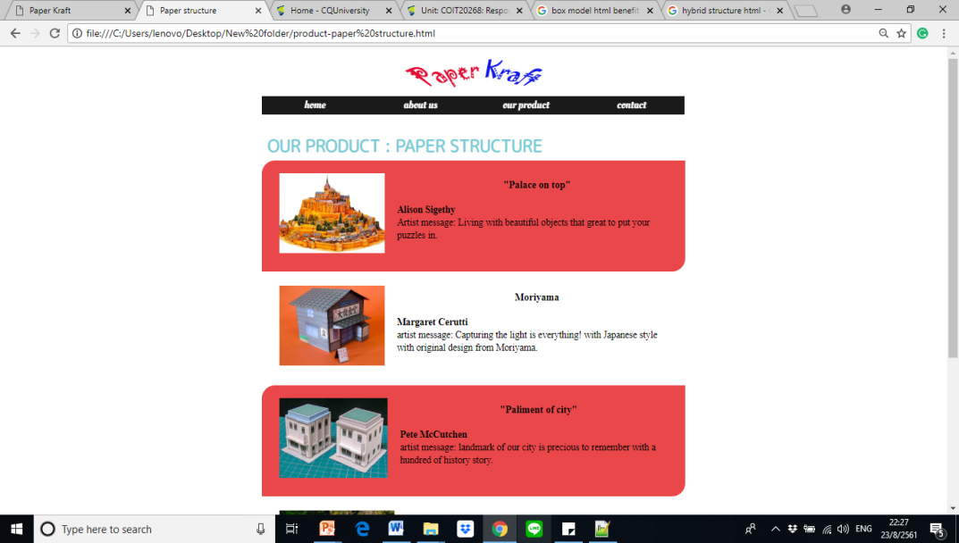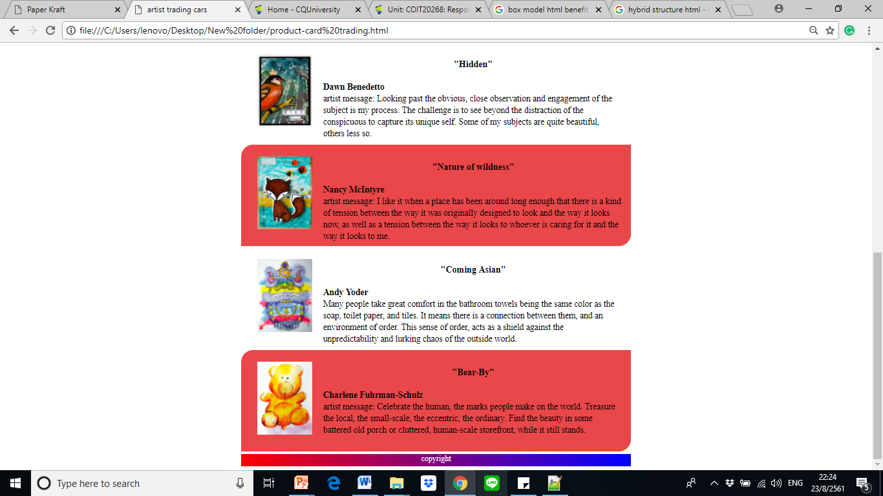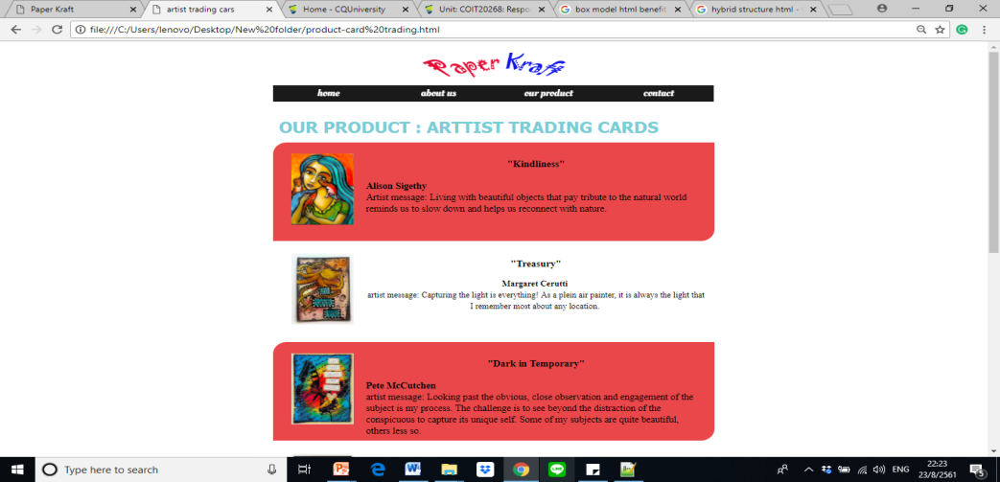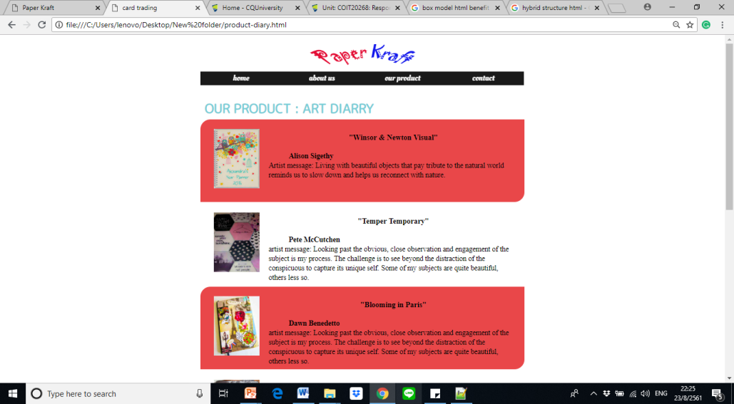

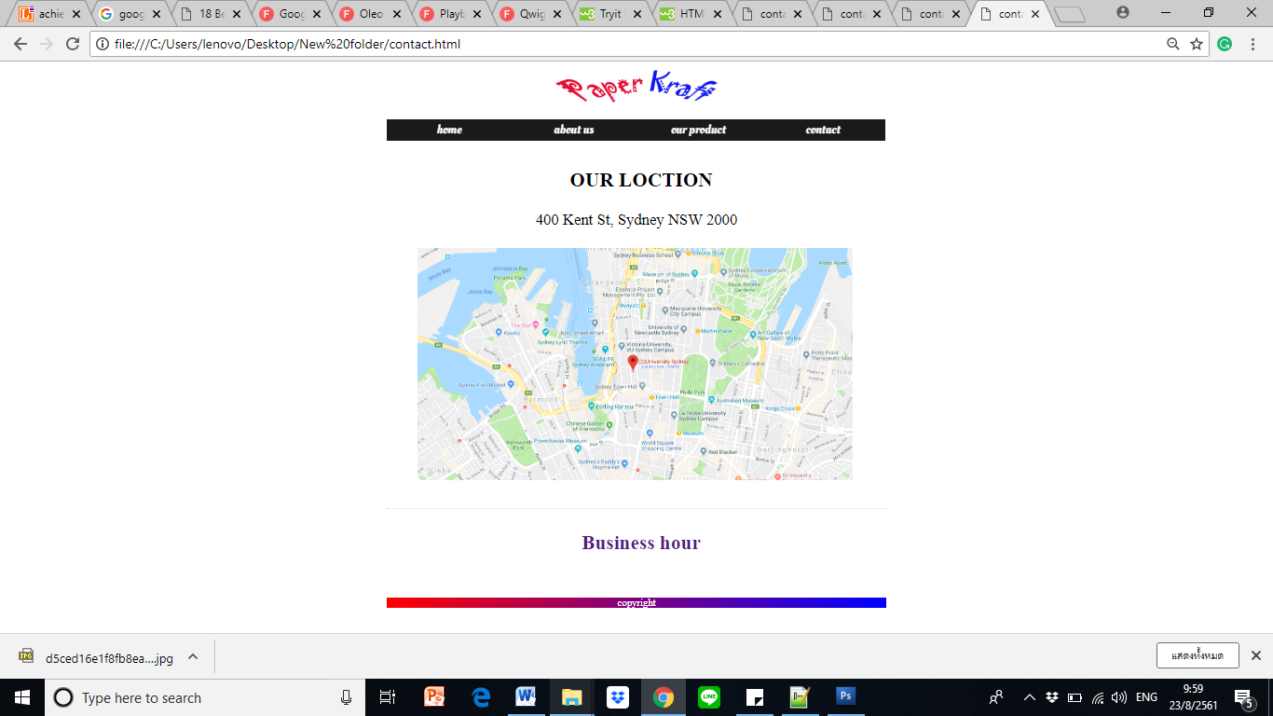

***h1*** {padding-left: 15px; text-align: center ;}

***p***  {text-align: center; font-size: 25px;}

***Img*** {align-img: center; width: 700px;}

***<a*** href="business hour.html" target="_blank">

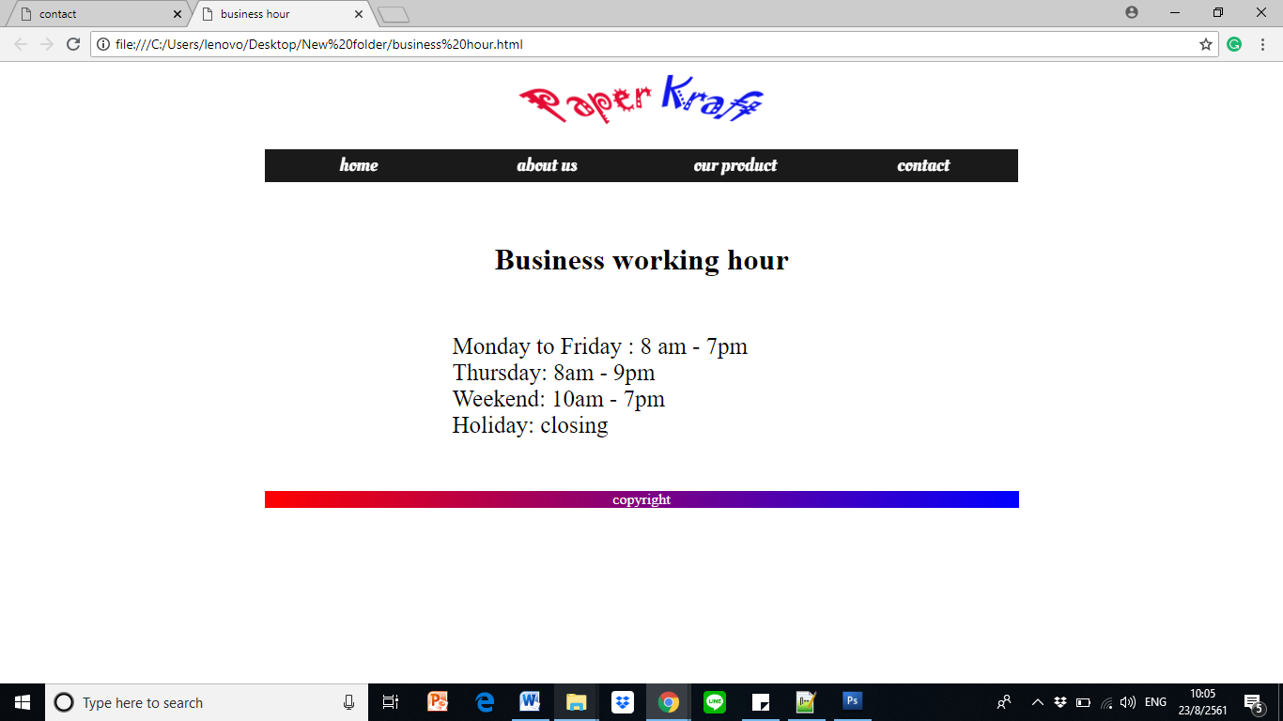

***h1*** {padding: 35px; text-size: 35px; text-align: center;}

***p*** {text-align: left; padding-left:200px ; font-size: 25px;}

**Portfolio 1.5**

What will be the typeface and styles for the body type and headings?

* To develop the website, I have imported the font type and style from outsource and also used some system fonts with heading 1, heading 2 and heading 3. In addition, I also apply the hand-writing style to welcome message area in the home page.

How many levels of headings are necessary?

* Three headings as h1, h2 and h3 are applied over this website.

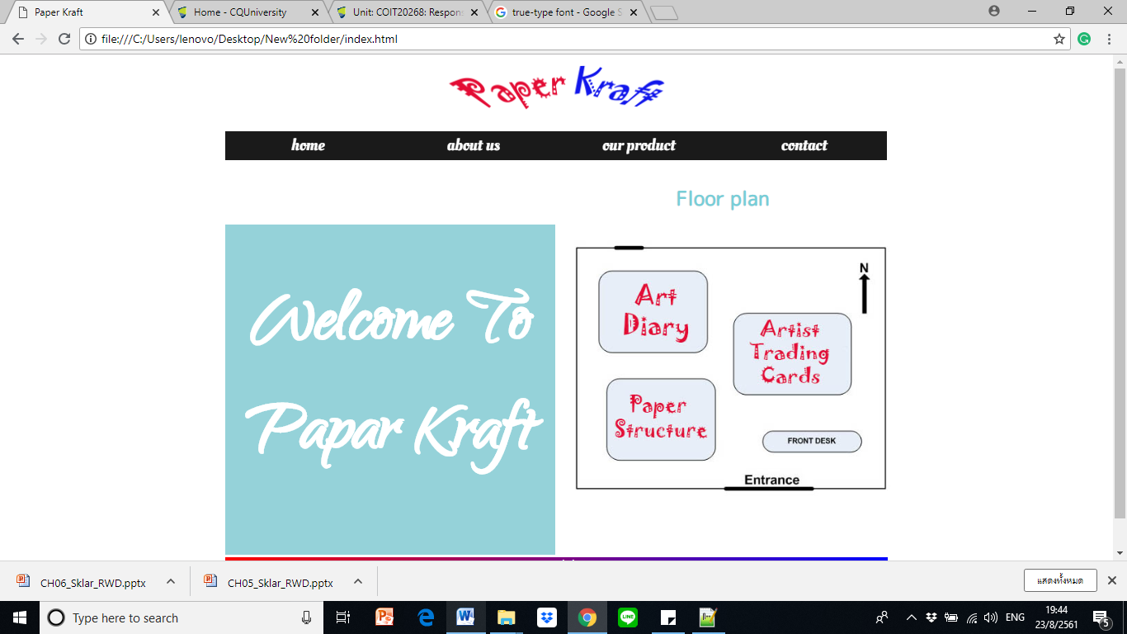

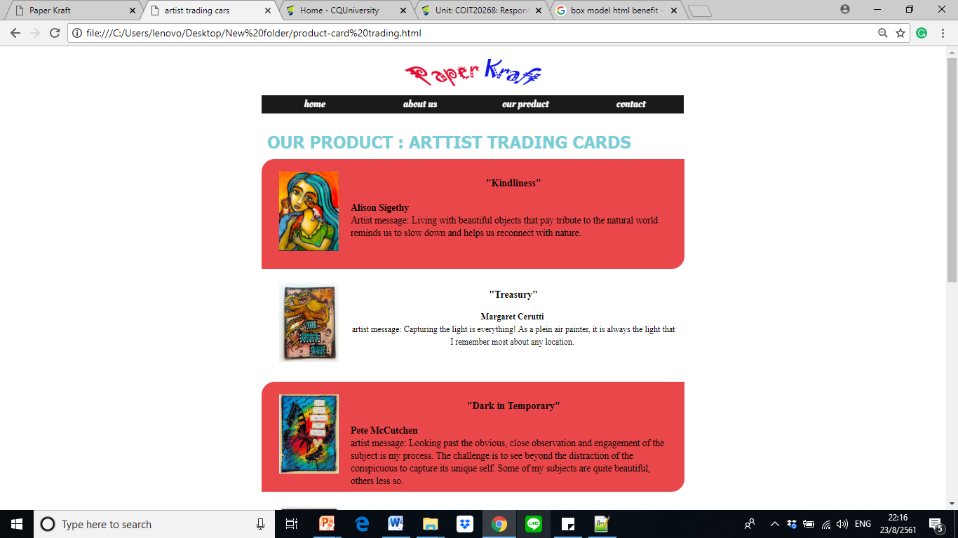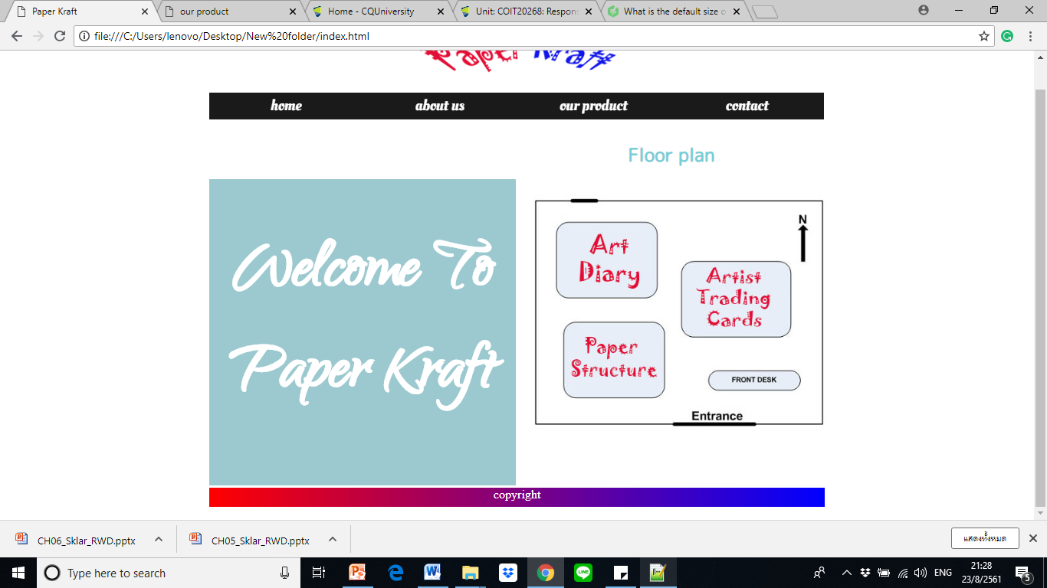

What are the different weights and sizes of the headings?

* Heading 1 is 32px, heading 2 is 24px and heading 3 is 18px which I applied in the website.
* Bold, shadow and italic are weight to emphasize in this website also.

How will text be emphasized?

* The text is emphasized by variety of color, font family, shadow, size, bold and italic style and also some alignment.

Will hypertext links be standard or custom colors?

* I designed two different hypertext styles as hypertext link with wording and picture to connect to other pages.
* For instance, I specified picture map area as {"rect" coords="261,134,413,229" alt="artist trading card product" href="product-card trading.html"/} which can link to artist trading card page.
* In addition, some of the hypertext link was created to pop up in the new target webpage. For instance, business working hour’s page will be show when click on the hyperlink by contact’s page with coding as {a href="business hour.html" target="_blank" }



How will you ensure the legibility and readability of your text?

* The font color, font family, size, style and also the background color are the detail of information which I was considered to end-user in case of readability and legibility. I applied them with the proper direction such as using contrast color between font, white space and background and using size greater than 16px which is readable easily.

What will you line length be?

In this website, I used the {line-height: 150%;} for <div class= “block”> to increase the line spacing between the word with product category.

**Portfolio 1.6**

Box model is the design that illustrates many benefits especially when using the flexible layouts.

This website was compounded with many box properties. For instance, our product page: using box design which contain image, text and applied with shadow as following property and attribute. *{ box-shadow: 0 4px 8px rgba (0,0,0,0.6); transition:0.4s; width:200px; height: 250px; text-align: bottom; padding :25px 2px; font-size: 22px; float: left; margin:30px; background-color: white;}*

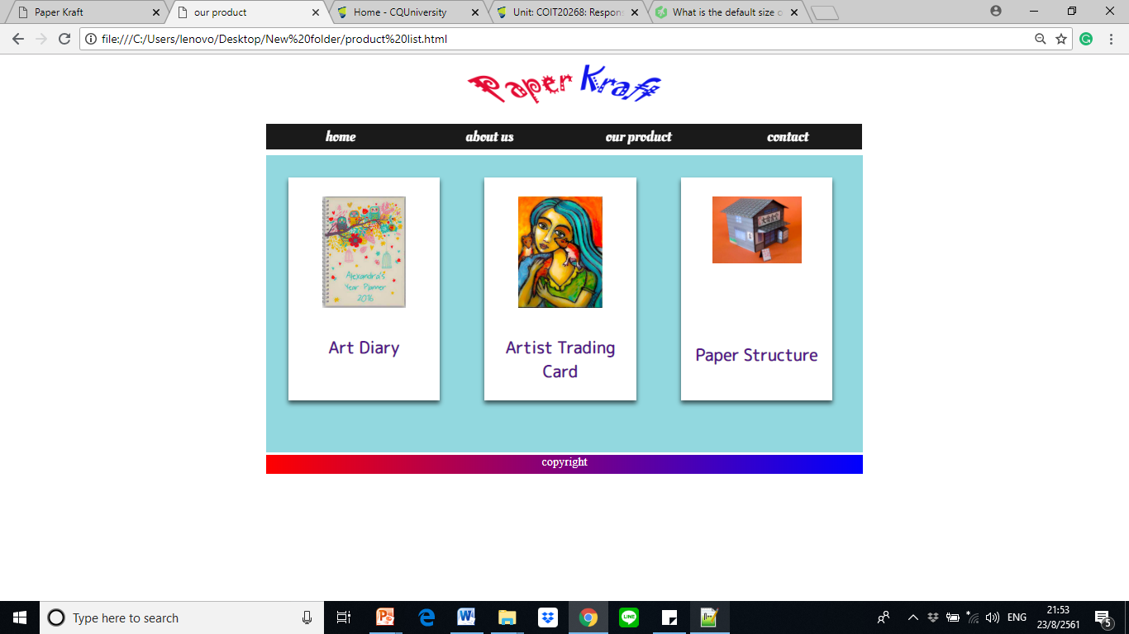

As well as, the box model was presented with all product information with following property and attribute.*{background-color:#37b49b; float: left; padding:15px; margin-bottom: 2px; width: 773px; height: 180px; font: 16px center; background-color: rgba(228,25,28,.8);* *border-top-left-radius: 25px; border-bottom-right-radius: 25px; }*

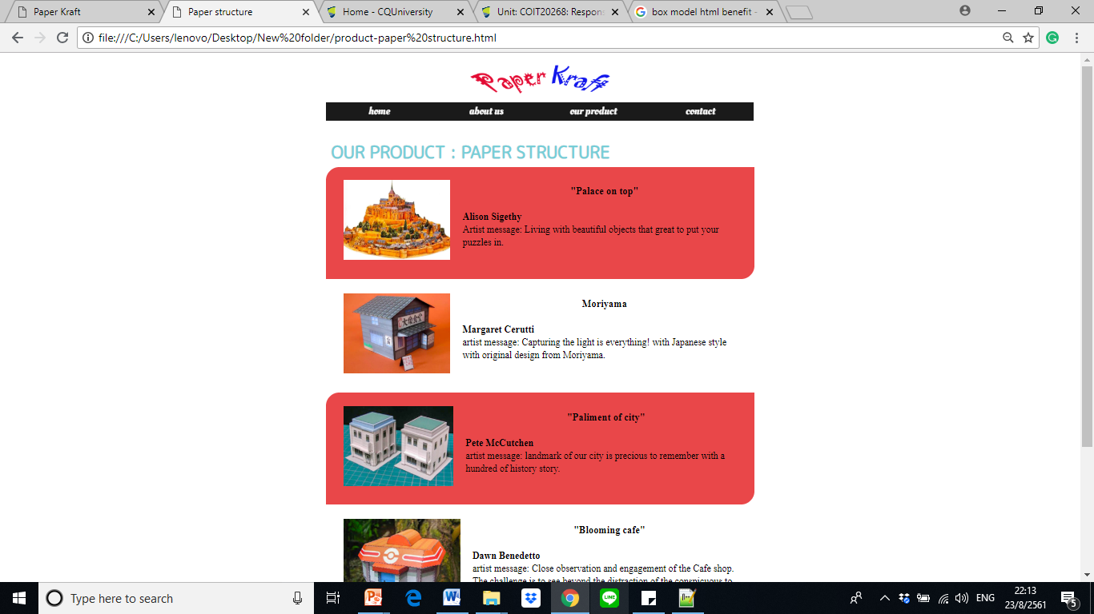

**Portfolio 1: Summary**

This report prepared the tailor information to guide and demonstrate the idea of developing Paper Kraft’s website.

Paper Kraft is the shop that sale three categories of the craft product. It targets to increase the sale amount by generating the new channel like a website. According to the target audience specification, designer classified into three groups as a female who age between 25-55 years old, children and school staffs as well as the wholesale and exporter.

During the planning stage, the team considered many points of view such as customer’s specification, navigation to use, the user’s insight, responsive design, theme and aesthetic of design as well as the effective hyperlink which offer the convenient to end user into various devices and attract the target group properly. However, the team also concerned some factor that would limit to end users such as usability skill, consistency design, browser, technology and platform, screen solution, accessibility, user disability as well as the poor connectivity and bandwidth.

Regarding the website’s content, developers created the main navigation compounding home, about us, our product and contact which are the first layer. In addition, they also design the sub-menu for “our product” session by categorizing into art diary, artist trading card and paper structure that demonstrate entire detail of each product. In the other hand, the team also used the image map to connect with another page directly such as the hyperlink over floor plan picture in the home’s webpage that includes and the other as our product’s webpage which embedded hyperlink over three product boxes.

While completing the planning stage, the team initiated developing stage by drafting the hand-writing design draft (illustrates by portfolio 2) and convert those ideas into the wireframe in portfolio 3. Moreover, portfolio 3 was included some aspects such as how to measure the success, that was recommended by using SMART goal and analyst through Google Analytic tool. The success criteria will gather from an amount of website visitors, bounce rate, average time on page, sale amount after launch the website and also survey with satisfaction and feedback form. In addition, the other aspect was shown as a flow chart which explained the benefit of structure and also filename recording.

In the coding stage, portfolio 4 to 6 demonstrated the overall scope of coding include CSS with portfolio 4, the typeface with portfolio 5 and box method with portfolio 6.

By coding development, the team started by using the box method to separate the space area. For instance, homepage includes title area (displays logo), heading area(displays navigation), sidebar area(displays welcome message), content area (displays floor plan image) and footer area (displays copyright information). According to the typeface, developers imported the external link with font family of M PLUS Rounded 1c, Oleo Script and cursive to apply to some area of this website. Then, developers applied CSS by creating the file name as “style.css” to record the external style which focused on the aesthetic design that applied to overall pages. For example, class “grid” including column and row spacing and specify detail for each space with text alignment, margin, font style and color. In addition, developers also included CSS both of internal and inline style to identify particularly area which demonstrated some of the font family, color, weight, and style.